SINCE 1976, OUR “BIG DUMMY’S” MANUAL OF CB REPAIR HAS HELPED THOUSANDS!

“...Fantastic! The best I’ve read, and I’ve read at least 40 books by so-called experts.” (Mr. F.D.G., Odessa TX)

“…Learned more from your book in one hour than 3 weeks in electronics school.” (Mr. L.A., Lisbon OH)
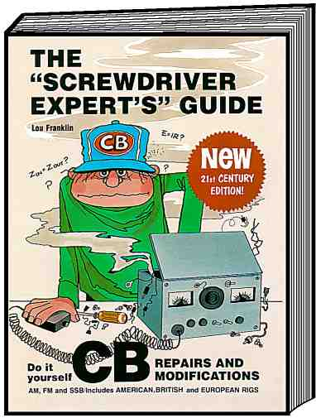
You can repair 95% of all CB radio problems yourself with NO ELECTRONIC knowledge, and NO expensive special test equipment. Just let my simple book, THE “SCREWDRIVER EXPERT’S” GUIDE, show you how.

Let me introduce myself. My name is Lou Franklin, and I am a professional electronic repairman with 35 years experience in the design and repair of radio communications equipment. I hold the highest grades of FCC licenses issued by the U.S. Government:

1. General Radiotelephone (formerly First Class Commercial) with Radar endorsement. The one most “repairmen” wish they could pass the test to get.
2. Amateur Extra Class (K6NH). Only 6% of all Ham operators can pass this test.

I have helped build, repair and maintain commercial broadcast stations around the world, including 100,000 watt, 6-tower AM/FM arrays. I have outlasted almost all my CB repair competition because quite frankly, I am among the best, the fastest, and the most honest CB technicians around. I have travelled the truck stops of America repairing the “repairs” of all the other so-called CB experts. I receive constant requests for technical advice from CBers all over the world.

There will never be a better time than right now for you to prepare yourself to cash in BIG on the booming CB radio repair business, without wasting a pile of money on overpriced correspondence school courses and vague electronics textbooks. Or maybe you just want to learn enough to fix your own equipment, and enjoy your hobby more. The popularity of CB is on the rise again, due mainly to lower overall costs, favorable sunspot conditions, and a growing interest by Hams in 10-Meter conversions. And CB is now a worldwide hobby, with millions of radios in use. People would still rather pay you $20-$30 for a simple repair, even on a bargain model, than have to spend considerably more for a new set. And they’re definitely not going to throw away a top quality name brand model. Finally, don’t expect those 23-channel sets to disappear for a long time: since they’re much easier to modify and tune than many of the 40-channel types, they’re still extremely popular with old-timers as well as Ham operators who can convert them for Amateur use. My book explains the pros and cons of both radio types, as well as their modification methods. I’ll show you in non-technical detail how to get those extra frequencies.

You’ll be the envy of all your radio friends. They’ll come to you for help and advice. And strangers will gladly pay you for the knowledge I’m offering. (The going repair rate is now about $40 per hour.)

In THE “SCREWDRIVER EXPERT’S” GUIDE (To Peaking Out & Repairing CB Radios), you’ll learn things like:

• How to “peak out” your transmitter, modulation, and receiver for greatest range and efficiency.
• How to wire any mike or power mike to any CB radio, or diagnose and repair mike-related problems.
• How to diagnose and repair the most common antenna/SWR problems.
• How to diagnose and replace bad “Finals” and crystals for about $3.
• Worthless gimmicks and junk products that don’t do anything.
• Tips on curing automobile ignition noise.
• The best brands to buy, and what to avoid.
• Methods of changing and adding channels for both crystal and PLL radios.
• How to add FM to many AM or AM/SSB models.
• How to unlock the Clarifier so that it also slides on Transmit.
• Specific power & modulation adjustments for hundreds of American and foreign PLL models.

In addition, you’ll learn once and for all the real dope on antennas and SWR with the most detailed, most comprehensive, and most practical discussion of this subject that anyone can understand. Those other guys are great with the math, but I

really doubt they’ve had their hands on as many real CB radio antennas and installations as I have. The myths about this least understood area of CB radio will be exposed at last.

My personal experience in repairing over 2,000 CB radios has shown that about 75% of all problems are not even in the radio; they’re almost always caused by bad mikes and bad antennas. Of the remaining 25%, perhaps 20% of all internal problems are the result of reversing the power leads, bad audio and transmitter “Finals,“ bad crystals, and bad solder connections. I can show you exactly how to diagnose such problems, how to physically locate and replace the defective part, and where to get an inexpensive new part. That leaves us with about 5% of problems requiring professional help and very expensive, special test equipment.

It is for this relatively small 5% that the electronics industry spends a fortune pushing their high-priced correspondence courses and vague theoretical textbooks. Such products often emphasize troubleshooting methods and classic analyses for problems which rarely even occur in CB radios. On the other hand, I’ve managed to boil down years of real, practical CB radio situations into an illustrated manual that anyone of average intelligence can understand. Electronics is a complicated science, but you don’t have to know how something works to be able to fix it. That’s why my information is totally unique: you just need eyes, common sense, and the ability to carefully follow illustrated instructions.

One word of caution: some of the repairs and adjustments that I’ll describe may be illegal for you to perform without the proper commercial FCC license, or under the supervision of a duly licensed technician. All I’m offering is the knowledge of how to do them.

This book is fully illustrated with drawings, charts, and schematics, including things like:

• Color codes of most popular power mikes and how to wire them.
• Common crystal mixing schemes for determining dead channels.
• The most common audio and RF Final transistor types, and how to recognize and replace them.
• How to locate the adjustments for “peaking out” the transmitter, modulation, and receiver sections of typical AM or AM/SSB rigs.
• How to convert many popular PLL radios to new frequencies by substituting crystals or by simple switching arrangements.
• Detailed SSB slider modifications. How to make them shift for both Receive and Transmit. Includes specific instructions for many popular chassis types.
• FM conversions. How to add this very useful operating mode to most AM or AM/SSB models.

Plus a unique Troubleshooting Flowchart! This method is often used by the pros to quickly isolate a fault or problem.

MONEY-BACK GUARANTEE! If for any reason you feel this information isn’t worth its purchase price, return it to me within 30 days for a prompt refund, no questions asked. (Ever wonder why those other CB mailorder “book” sellers never offer refund guarantees?) This book is professionally written, typeset and bound in a large 8½” x 11” format. Over its long history (since 1976!) it’s been reviewed in many electronic magazines including CB MAGAZINE, S9, SCIENCE & ELECTRONICS, and POPULAR COMMUNICATIONS.

You’ll be amazed that finally, somebody who really knows CBs can show you in plain language and pictures how to repair and tune your own radio, and frustrate all those fast buck “repair” artists out there. And who knows? Maybe you’ll even make some money yourself, or start an exciting career in electronics!

For all this valuable information, the price is only $25 plus shipping. It would easily cost you that much just to get a power mike wired, or to have an antenna repaired at any good CB shop. And after saving yourself that next repair bill, or receiving your first paid repair, you’ve already recovered the low purchase price. All future repairs are pure gravy for you!

Since our first edition, literally thousands of people have been helped by “THE SCREWDRIVER EXPERT’S” GUIDE. Here’s just a small sampling of the many unsolicited comments we’ve received from happy readers:

"…I am more than pleased. Everyone wants to know how I learned it so fast.” DFN, Canastota NY

“…Let me commend you for one of the finest books on CB repair that I have ever seen, and I’ve been a CBer for 16 years.” RBP, Beloit WI

“…A fantastic publication. I can understand it easily, having no electronic knowledge.” CC, Abilene TX

“…mobile…broken down for 3 months. I repaired it with your book’s help for $1.00…so my book is now paid for.” GD, Canada

“…has helped me fix several radios. It is so simple, the best I’ve read.” CW, Scottown OH

“…was a big help to me…the easiest one to understand and read…worth…paying that cheap price.” RN, Honolulu HI

(continued on next page)
“…is one of the very best and very easiest on the subject; you get the information across.” MP, Argyle, MN

“…I found your book…very interesting and helpful in understanding CB radio problems.” DM, Wheaton MD

“…It has proved to be quite useful.” TK, Holly MI

“…simply ‘bodacious.’…Your book is of great value to me.” OE, Ontario CA

“…the most important item anyone could add to their radio shack. To you sir, ‘Well Done!’ and thanks!” LL, Las Cruces NM

“…a little more than I expected. A real fine book by far.” EM, Beeville TX

“…I recommend this book to every CBer. It has helped me in all ways.” HK, Netherlands Antilles

“…great, fantastic, there is someone who can explain a technical subject in a non-technical way.” LH, Rialto CA

“…the best, most informative, to the point book I have found on CB basic repairs.” RR, Jacksonville OR

“…the best publication I have ever seen. Thank you very much for a job well done.” WGB, Collinsville IL

“…one of the best…ever done to explain to a novice repairman how to fix his own equipment…Maybe I can avoid being ripped off by some
first class know-it-all.” RSS, Rockford IL

“…was just the thing I needed. Took all kinds of courses, but this one was the one that did it. Thank you.” RBH, Bolivar PA

“…very, very informative and very helpful.” APT, Pittsburgh PA

“…I am very satisfied with what I’ve read.” CW, Pittsburgh PA

“…was worth the wait. It is very interesting and I feel very well written.” JS, Cherryfield ME

“…the most informative compilation of information I have ever had the fortune to read.” AD, New York NY

“…the best instruction book that I own. I keep re-reading it for all those helpful hints and always benefit.” GB, Woodsville NH

“…real good and well worth the money.” DM, Gibson LA

“…So far…have repaired 4 radios that did not work for only $2.” EBA, Austin MN

“…Your manual on CBs has helped me quite a bit.” JW, Gibson GA

“…I bought your CB repair book which I found quite helpful on several occasions.” RB, Cleveland OH

“…is very helpful and real good.” MK, Cumberland MD

“…I enjoyed reading your very comprehensive book.” JM, Daytona Beach FL

“…have thoroughly enjoyed it. It has given me a lot of insight.” HWS, North Royalton OH

“…your book…is fantastic. I have taken a CB radio course which helped me get my license but your book has helped me
fix the radios.” RLB, Hillsville VA

Well that’s my sales pitch, so thanks for taking the time to read all this. Remember you’ve got a 100% money-back guarantee, no questions asked. To order your copy, return the enclosed Order Form or a letter along with your payment or credit card information. But HURRY! The FCC has already tried to ban parts of this book.
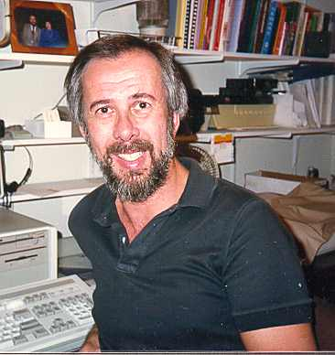
73,

Lou Franklin, K6NH / "SuperSparks”

P.S. Please pass this information along to a CB friend or club. And if you’re already familiar with basic CB electronics and are ready to learn a lot more, check out our big advanced technical book, UNDERSTANDING & REPAIRING CB RADIOS.
Published by:
CBC INTERNATIONAL • P.O. BOX 30655 • TUCSON AZ 85751 U.S.A.
TEL/FAX: 888-I-FIX-CBs (1-888-434-9227), (520) 298-7980
Internet: www.cbcintl.com • Email: Use email links at www.cbcintl.com
UNDERSTANDING & REPAIRING CB RADIOS
THE BIGGEST, MOST AMBITIOUS CB RADIO BOOK EVER WRITTEN! OVER 370 PAGES OF DETAILED THEORY & TROUBLESHOOTING INSTRUCTIONS. ILLUSTRATED THROUGHOUT WITH MORE THAN 350 PHOTOS, CHARTS, SCHEMATICS, & OTHER DRAWINGS!
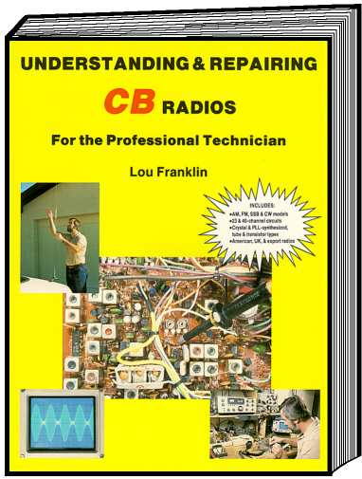

COVERS ALL TYPES OF CB RADIOS:

• AM, FM, SSB, & CW
• 23- & 40-CHANNEL
• CRYSTAL & PLL-SYNTHESIZED
• TUBE & SOLID-STATE
• AMERICAN, BRITISH, & EXPORT MODELS

ISBN 0-943132-24-X
384 pages with index
8½" x 11" soft cover

We’ve had thousands of requests from happy readers for a more detailed technical reference that would pick up where THE “SCREWDRIVER EXPERT’S” GUIDE leaves off. And so I’ve created the “ultimate” CB radio book. (Nearly four times bigger too!) It took more than three years, and you won’t be disappointed.

If you’re a student of electronics, a professional radio technician or retailer, or just someone who takes his CB hobby seriously, this book is for you. This comprehensive teaching manual is designed to help you solve any type of CB radio problem, quickly and profitably. As you know, CB interest is on the rise again. Combined with the new 10-Meter Novice Ham band, this means thousands of CB radios will need service and repairs, as well as qualified technicians to do the actual conversions. Get the education you need to cash in on the boom!

You probably already have a knowledge of basic electronics that you got through work experience, school, a correspondence course, or more general books. But you could never seem to relate that knowledge specifically to CB circuits. Look no further! Starting with a detailed discussion of CB technical specifications and measuring equipment, you’ll be guided through various troubleshooting techniques and shortcuts. This is followed by a thorough analysis of virtually every type of circuit found in CB radios, from the classic 23-channel tube transceivers to the most modern multimode solid-state models. A big chapter on antennas, their problems and installation tops it off. Details on where to find specific parts, accessories, test equipment, and more information are included throughout the huge text. There’s no complicated math or vague theory here; just practical, common CB circuits explained in the simplest possible way.

Here’s a small sampling of the fact-filled contents:

CHAPTER 1 — INTRODUCTION TO CB SERVICING
The new Surface Mount technology. CB technical specs defined. Test equipment you’ll need. Inexpensive testing aids you can build yourself. Additional information sources. Includes a complete shopping section for CB radios, antennas, parts, accessories, and test equipment including names, addresses, and “800” numbers. Plus much more!

CHAPTER 2 — BASIC TROUBLESHOOTING TECHNIQUES
Block diagrams teach you theory of AM and FM receivers and transmitters. Use of the systematic approach. Testing semiconductors. Signal injection and signal tracing. Intermittents. Interpreting DC biases. Transistor amplifier circuits. Understanding device markings. Plus much more!
(continued on next page)
CHAPTER 3 — GENERATING THE SIGNAL FREQUENCIES
Crystals and crystal oscillators. Series and parallel resonance. The Colpitts Oscillator. Overtone oscillators. Oscillator troubleshooting. How to order crystals. Walkie-Talkies. The VFO, Crystal and PLL synthesizers. Elements of the PLL system. How digital dividers work. Generating the binary and BCD channel codes. ROM programming. Additional PLL functions. Expanded coverage synthesizer methods. Broadbanding methods. Evolution of the PLL using several examples. PLL alignment procedures and equipment set-up. PLL troubleshooting methods. The MB8719 synthesizer. Includes 23-channel crystal mixing charts covering 90% of all AM CBs; use these to quickly determine dead channels or 10-Meter Ham conversions. Plus much more!

CHAPTER 4 — RECEIVER CIRCUITS
RF and IF Amplifiers. Mixers. Single- vs. dual-conversion methods. IF selectivity methods plus tips on improving them. IF troubleshooting. Detector circuits. ANL circuits. AGC circuits. AGC troubleshooting. The S-Meter circuit. Noise Blankers. NB troubleshooting. FM detector circuits. FM receiver troubleshooting. Squelch circuits. Squelch troubleshooting. Scanning circuits. Selective calling. The audio amplifiers. Audio troubleshooting. LED channel displays and bar/graph displays. Delta Tune circuits. Tone controls. Receiver alignment procedures and equipment set-up. Plus much more!

CHAPTER 5 — TRANSMITTER CIRCUITS
The RF amplifier chain. Oscillators, mixers and buffer stages. Power amplifiers. Classes of amplifier operation. Biasing methods. Vacuum tube power amps. Power doubling methods. Power reduction methods. Coupling and filtering. AM and FM modulation methods. Speech processing. Mikes and mike problems. Limiters and compressors. Measuring and adjusting modulation. RF Power Meter circuit. Modulation meter circuit. SWR Meter circuit. Antenna Warning circuit. Roger Beep Oscillator circuit. CW keying circuit. Selective calling circuit. Transmitter alignment procedures and equipment set-up. Plus much more!

CHAPTER 6 — SINGLE-SIDEBAND CIRCUITS
SSB characteristics, pros and cons. SSB signal generation. The Carrier Oscillator. Carrier and synthesizer offset methods. The speech amplifier. The Balanced Modulator. BM troubleshooting. Sideband selection methods. SSB crystal filters. The mixer. Mixer troubleshooting. Linear RF power amplifiers. Biasing methods. AM/SSB power and modulation control. ALC. Testing the SSB transmitter. SSB reception methods. The Balanced Demodulator. The Product Detector. The Clarifier circuit. Clarifier troubleshooting. IF amplifiers. SSB AGC methods. SSB transceiver alignment procedures and equipment set-up. Plus much more!

CHAPTER 7 — POWER SUPPLIES AND T/R SWITCHING
The mobile DC power supply. Ground loops. Electronic and relay T/R switching circuits. Voltage regulation circuits. The base station AC/DC power supply. The solid-state base supply. Tube and hybrid power supplies. DC-to-DC power supplies. Multimode transceiver power supplies. Includes use of SAMS Fotofacts schematics for step-by-step analysis of several common power circuits. Troubleshooting the power supply. Plus much more!

CHAPTER 8 — ANTENNAS AND TRANSMISSION LINES
Mobile antenna types and mounting hardware. 27 MHz characteristics. The ½-wave antenna. Reactance and tuning. Impedance and radiation resistance. The Standing Wave Ratio (SWR). Coax length vs. SWR. Coax characteristics. Effect of in-line accessories. Coax losses vs. SWR losses. Some practical coax tips. Bandwidth. Gain and directivity. Radiation patterns and field strength. Omnidirectional antennas. Loading coils. Directional mobile antennas. The Quad and Yagi beam, including dimensions for home construction. The PDL. Antenna matching principles. Tuning and troubleshooting the mobile whip. Magnetic antennas. Co-phasing simplified. Co-phase matching tips. Use of dummy loads in troubleshooting. Matching high-Z verticals. Matching Quad and Yagi beams. Stacking beams for increased gain. Preventing TVI. Matching special CB antenna types. Plus much more!

APPENDIX A — SOLVING NOISE AND INTERFERENCE PROBLEMS
TVI and RFI. Front-end overload. Audio interference. Ignition and other automotive noise problems. Includes reference data and parts suppliers.

APPENDIX B — FCC FREQUENCY CHART
Quick reference 40-Channel frequency listings including tolerances.

INDEX
Thousands of entries covering virtually every related subject. Lets you troubleshoot a specific problem by looking up its symptom here.

This is the cheapest education in CB radio servicing you’ll ever get! (And most likely the only modern book on the subject you’ll ever find.) Completely illustrated throughout. Hundreds of tips to make you money and impress customers with your technical knowledge. SATISFACTION GUARANTEED!

Also available in many public libraries all over the U.S.!
Ask yours if it’s in their Card Catalog yet.

Published by:
CBC INTERNATIONAL • P.O. BOX 30655 • TUCSON AZ 85751 U.S.A.
TEL/FAX: 888-I-FIX-CBs (1-888-434-9227), (520) 298-7980
Internet: www.cbcintl.com • Email: Use email links at www.cbcintl.com

WANT LOTS MORE CB CHANNELS
OR AN EASY HAM CONVERSION?

WANT TO BE THE LOCAL PLL EXPERT
THAT OTHERS ASK FOR ADVICE OR SERVICE?
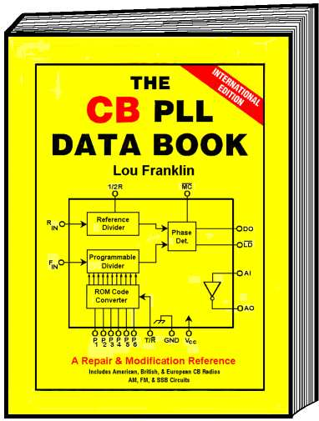

THE CB PLL DATA BOOK
SHOWS YOU HOW!
NEW INTERNATIONAL EDITION

8½" x 11" Softcover
88 pages, 43 illustrations, 10 charts
ISBN 0-943132-05-3
HERE’S THE MOST COMPREHENSIVE, EASY-TO-UNDERSTAND REFERENCE GUIDE TO CB PLL CIRCUITS YOU’LL EVER NEED. COMPLETELY REVISED
AND EXPANDED TO INCLUDE ALL
THE LATEST CHIP TECHNOLOGY.
Now you don't have to be an electronic genius to understand PLL synthesizer circuits and frequency modifications. Using the same clear style of non-technical writing style that made his classic book, THE “SCREWDRIVER EXPERT’S” GUIDE so popular, author Lou Franklin unravels the mysteries of the PLL circuit for both beginners and professional repairmen.

Become a PLL expert the lazy man’s way. We've combined hundreds of CB models and years of PLL experience into a single handy reference source. “How can I unlock the PLL02A for more channels?” “What’s the function of Pin 9 on the LC7131?” “Which radios are the easiest and hardest to convert?” The answers to these questions and many more are all here!

FEATURES:
• How the PLL works. Simple but detailed text and illustrations, all carefully prepared and written for the average person.

• How to modify the PLL for many more channels or the 10-Meter Ham band.

• How the PLL is used for the SSB “slider” shift and for FM transmission.

• How and where the PLL provides all the required mixing signals for CB operation.

• How the major CB manufacturers easily convert 40-channel American rigs into “export” models which often have up to 240 channels.

• Pin-by-pin functional description for nearly every PLL device used, old or new. Includes U.S., U.K., and European chips, plus manufacturers’ cross references.

• Specific lists of every known CB radio using a particular PLL chip, grouped by chip type and chassis type. All the latest U.S. and export radios included.
(continued on next page)
In THE CB PLL DATA BOOK, you’ll have all available information at your fingertips for the following PLL devices:

C5121
CC13001
CC13002
HD42851
HD42853
KM5624
LC7110
LC7113
LC7120
LC7130
LC7131
LC7132
LC7135
LC7136/37
LC7185
M58472P
M58473P
MB8719/8734
MB8733
MC14526/MC14568
MC145104
MC145106
MC145107
MC145109
MM55104/114/124
MM55106/116/126
MM55107
MM55108
MN6040/MN6040A
MSC42502P
MSM5807
MSM5907
NDC40013
NIS7261A
NIS7264B
PLL01A
PLL02A
PLL03A
PLL08A
REC86345
SM5104
SM5107
SM5109
SM5118
SM5123A
SM5124A
SM5125B
TC5080P
TC9100P
TC9102P
TC9103P
TC9106P
TC9109P
TC9119P
μPD858C
μPD861C
μPD2810C
μPD2812C
μPD2814C
μPD2816C
μPD2824C

Also included is a unique section of specially prepared PLL chassis diagrams. These are simplified illustrations showing exactly how a particular chip is used to generate all IF frequencies, downmix frequencies, Clarifier and SSB offsets, etc. Easier to understand than the manufacturers’ own service manuals! Covers all the most common chassis, including:

CPI 300/400/2000
LC7120 AM & SSB
LC7130/31/35/36/37 AM & FM
LC7131 SSB
LC7185
MB8719 SSB
NDI SSB (early)
NDI SSB (late)
PLL02A AM 2-xtal
PLL02A AM 3-xtal
PLL02A SSB (U.S. & export)
PLL03A/08A AM & FM
REC86345 AM
SM5104 SSB
SM5123A
SM5124A
SM5125AM
TC5080 SSB
TC9106/9119 AM & FM
TC9109/LC7132/MB8733/C5121
μPD858 AM 2-xtal
μPD858 AM 3-xtal
μPD858 SSB
μPD861 AM ROM
μPD861 AM Binary
μPD2814/2816 AM
μPD2816 SSB
μPD2824 SSB

Plus special diagrams for the Cobra 148GTL-DX, Realistic TRC459, and Uniden HR2510 chassis.

This is the only reference especially written to include non-technical people and serious repairmen. Professionally typeset, bound and illustrated, the big new International Edition covers all the most popular, classic PLL circuits. Plus all the very latest state-of-the-art devices in CB use worldwide.

Don’t be left guessing — learn the tricks of the trade now. This is “must” reading for every true CB hobbyist or serviceman!

Published by:
CBC INTERNATIONAL • P.O. BOX 30655 • TUCSON AZ 85751 U.S.A.
TEL/FAX: 888-I-FIX-CBs (1-888-434-9227), (520) 298-7980
Internet: www.cbcintl.com • Email: Use email links at www.cbcintl.com

BOOST YOUR “TALK POWER” AND RANGE

Blow Their Ears Off With DYNAMIC SPEECH PROCESSING!

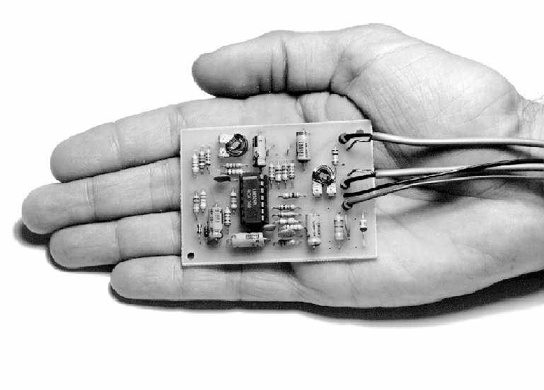
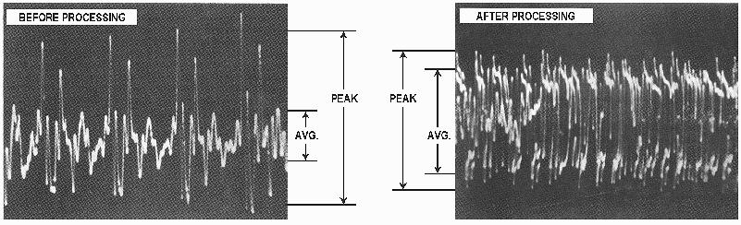
Ever wonder why those Rock ’N Roll radio stations always seem so loud? Or why TV commercials seem to be louder than the program itself? The reason is because smart broadcasters use exactly the same modulation processing that’s now yours in this simple add-on device. You won’t find this circuitry in the average radio; it would cost a lot more. And the sophisticated design requires too many parts to fit inside a power mike.

Your voice only modulates a transmitter about 30% on the average. So during a one-minute transmission, you’re really only hitting full RF power output for about 20 seconds; the other 40 seconds are wasted energy. Here’s why: almost all of the voice power is concentrated in the consonant sounds (B, K, S, etc.). The vowel sounds (A, E, I, O, U) contain very little average power and can cause high-intensity peaks which easily overmodulate a transmitter, causing channel splatter and “bleedover.” Also, voice frequencies below 500 Hz and above 3000 Hz contain little power and don’t really improve voice communications. By using our DYNAMIC SPEECH PROCESSOR, all those unwanted frequencies are reduced while at the same time the high intensity peaks are “clipped off.” The ’scope photos show how the DSP effectively raises the average power relative to the peak power. The result is a dramatic increase in perceived loudness by the listener, to about 90% average modulation. Now you’re running at full RF power output almost all the time! And the best part is that proper adjustment of the DSP output eliminates overmodulation and channel bleedover while letting your voice punch through LOUD!
NEW TRANSMITTER ACCESSORY
IS CHEAPER & MORE EFFECTIVE THAN ANY POWER MIKE.

KIT $42 PLUS $4 SHIPPING

(PLANS & PC BOARD MAY BE PURCHASED SEPARATELY.)

FEATURES:
• 6 dB improvement (one S-unit) in AM/SSB audio power with little or no distortion. Improves communications during
heavy interference or weak-signal conditions.
• Prevents overmodulation “bleedover” while maintaining extremely high average modulation. Over 30 dB of dynamic
range is compressed to modulation levels averaging 90%, even when you whisper!
• Harmonic and RC filtering assure clean, problem free audio signal.
• Powerful IC design is equal to 15 transistors. Adjustable clipping and output controls to match any situation or radio; works with any CB or HAM transceiver. Jumper options to match any stock mike, power mike, high or low impedance.
• Simple installation. Small size (3" x 2¼") fits easily inside radio. Connects to mike wires. Powered by the radio’s own +12 VDC supply. (Only 15 mA current drain.) Includes instructions for separate box mounting if desired.
Manufactured by:
CBC INTERNATIONAL • P.O. BOX 30655 • TUCSON AZ 85751 U.S.A.
TEL/FAX: 888-I-FIX-CBs (1-888-434-9227), (520) 298-7980
Internet: www.cbcintl.com • Email: Use email links at www.cbcintl.com
SICK OF CHANNEL BLEEDOVER INTERFERENCE?

The Answer — the CHANNEL GUARD. A unique active IF selectivity filter that wipes out CB's most annoying problem once and for all.
455 KHz
(DISCONTINUED;
USE 10.695 MHz*) 7.8 MHz & 10.695 MHz
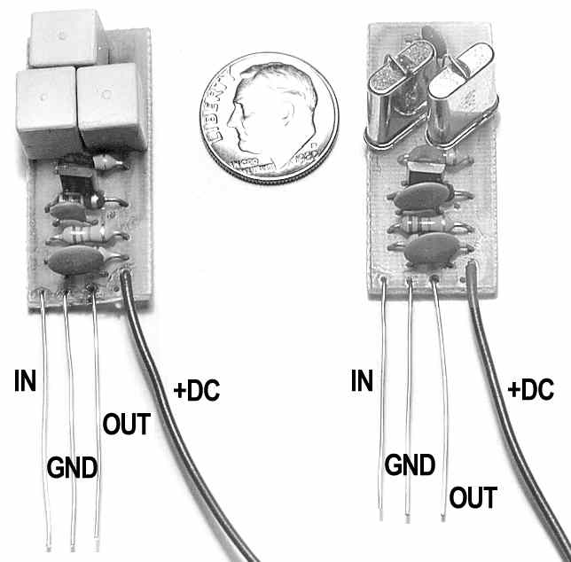
Fits all PLL- or crystal-synthesized CB radios that use a 7.8 MHz or 10.695 MHz IF frequency.* Installs in minutes with common tools and no special knowledge. Works on AM, FM, or SSB.

CB is popular. Maybe even too popular. Either the skip cycle is in, with great DX to crowd every channel, and all the Hams converting CBs to 10 Meters. Or the skip is dead, so every local guy in town seems to be busy talking to his neighbor at the same time as you. Many stations are overpowered and overmodulated, and are guaranteed to make your operating miserable with splatter and bleedover. Fed up with hearing the guy down the street ten channels away? The CHANNEL GUARD will stop him cold!

We have two CHANNEL GUARD filters to fit the most common IF frequencies of popular crystal and PLL type radios: 7.8 MHz, and 10.695 MHz. SHOWN ACTUAL SIZE

These high-frequency versions are especially useful for SSB rigs. Simply remove the correct IF coupling capacitor shown in the detailed instructions, install the INPUT/OUTPUT leads and GROUND, and connect to +8-13 VDC. You are done!

The old 455 KHz filter (photo) we once made for AM and AM/FM models is now discontinued. But the newer CBs almost always use a 10.695 MHz second or high IF; our 10.695 MHz filter can be used in them with even better results. That’s because crystal filters are much sharper than the ceramic types commonly used for 455 KHz. Just be sure to specify your radio model when ordering it.

The CHANNEL GUARD combines an IF amplifier stage with two high-Q crystal elements. You install it at an early IF signal point, before the signal branches off to the separate AM, FM, or SSB detectors. The result — razor-sharp selectivity in every mode. Since the “Q” (Selectivity Factor) of a crystal is many times higher than the normal tuned IF transformers, the strength of interfering signals even slightly off the center IF frequency drop off very quickly. Bleedover is greatly reduced. See the graph at the left.
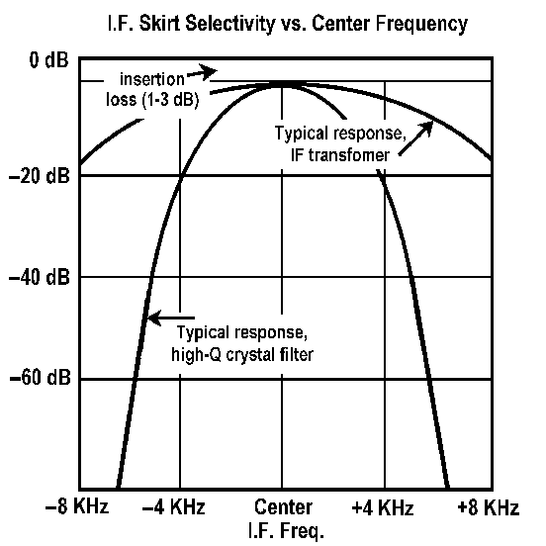
FEATURES:
• Provides up to 100 dB adjacent-channel rejection. This is much better than the majority of CB transceivers, which typically specify only –40 to –60 dB. A factor of “100 dB” means that any signal outside the normal 10 KHz CB channel spacing is reduced in strength by a factor of 10 billion from channel center. Turn your ordinary rig into a hot performer!
• No reduction in receiver sensitivity. In fact, the CHANNEL GUARD adds one stage of amplification at the 7most critical point—right in between IF filtering stages. You may even hear those weak signals that you missed before.
• Every REACT monitor needs one to eliminate Channel 9 bleedover.
• Quality components used. Each CHANNEL GUARD is hand-made and thoroughly checked
against a powerful 30,000 µV modulated test signal. Just solder it in and forget it!

SPECIAL NOTE: Our 10.695 MHz CG filter really cleans up all the Uniden & Cybernet “export” or 10-Meter “Amateur” radios and CB lookalikes. And in every mode, AM, FM, or SSB! (They’re all clones of the Uniden receiver circuit.) Examples include Uniden HR2510/HR2600, Cherokee, Connex, Eagle, Galaxy, Ham Int’l, Magnum, Mirage, Northstar, RCI–Ranger, Superstar, TriStar, etc.

*NOTE: Most SSB CBs use these IF frequencies. Those with a 455 KHz IF use it only for AM and/or FM. A few older SSB models used IFs such as 11.275 MHz. We also have a limited number of 11.275 MHz monolithic crystal filters available for these CBs. If in doubt about your radio, send us an email or a large stamped SASE with the exact model and we can advise you which one to order.
Manufactured by:
CBC INTERNATIONAL • P.O. BOX 30655 • TUCSON AZ 85751 U.S.A.
TEL/FAX: 888-I-FIX-CBs (1-888-434-9227), (520) 298-7980
Internet: www.cbcintl.com • Email: Use email links at www.cbcintl.com

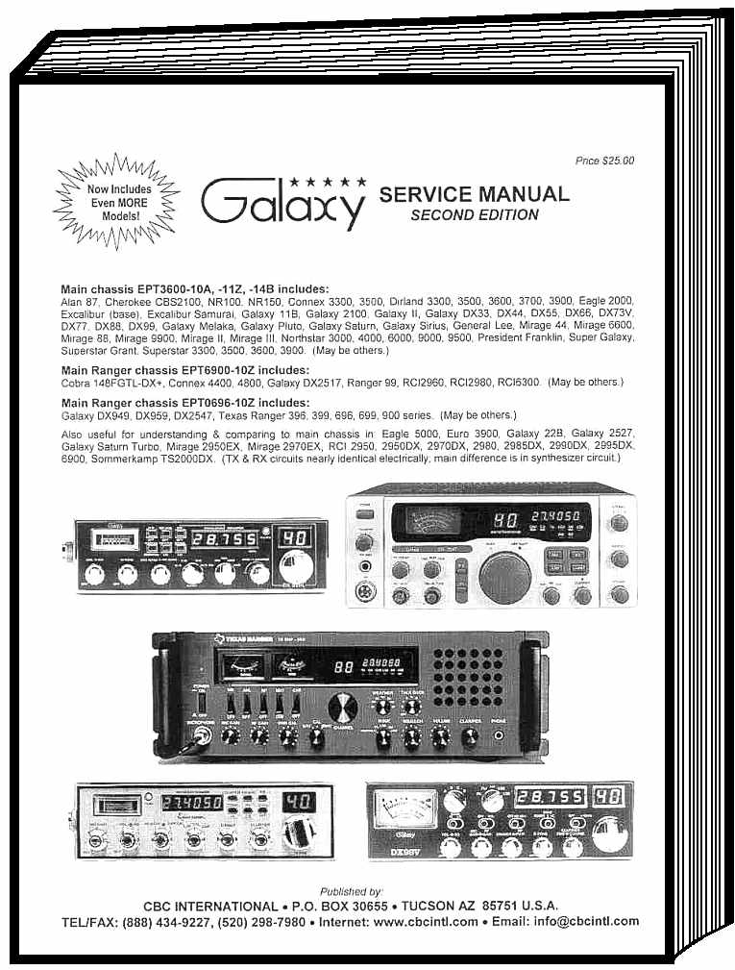The latest edition of our service manual for these popular Galaxy and Ranger radios has been expanded to cover even more models. No more fuzzy photocopies of schematics that you can't read no matter how large. No more guessing about all the other essential technical information you must have, like voltage measurements, PLL and circuit theory, block diagrams, 'scope photos, alignment procedures, and much more.

SERVICE MANUAL
Second Edition

This expanded new 32-page book was completely written and illustrated by Lou Franklin in his famous crystal-clear style. The schematics are all redrawn for greater clarity in 11" x 17" sizes, with active stages and trimmer adjustments plainly labelled, and part numbers converted to the American style (".047µF" instead of "473M", etc.).

Most of the models listed below were made by Ranger Communications Inc. (RCI) and based on the original Uniden PB010 export chassis described in our popular UNIDEN EXPORT SERVICE MANUAL. Those that Ranger didn’t actually make are usually Chinese or European copies with identical circuits and sometimes even the same parts numbers. Study this one book and you'll understand all of them!

Main chassis EPT3600-10A, -11Z, -14B includes:
Alan 87, 8001, Cherokee CBS2100, NR100, NR150, Connex 3300, 3500, Dirland 3300, 3500, 3600, 3700, 3900, Eagle 2000, Excalibur (base), Excalibur Samurai, Galaxy 11B, Galaxy 2100, Galaxy II, Galaxy DX33, DX44, DX55, DX66, DX73V, DX77, DX88, DX99, Galaxy Jupiter, Galaxy Melaka, Galaxy Pluto, Galaxy Saturn, Galaxy Sirius, General Lee, Mirage 44, Mirage 6600, Mirage 88, Mirage 9900, Mirage II, Mirage III, Northstar 3000, 4000, 6000, 9000, 9500, President Franklin, Ranger VR-9000, Super Galaxy, Superstar Grant, Superstar 3300, 3500, 3600, 3900. (May be others.)

Main Ranger chassis EPT6900-10Z includes:
Cobra 148FGTL-DX+, Connex 4400, 4800, Galaxy DX45MP, DX48T, DX93T, DX95T, DX2517, General Grant,
General Stonewall Jackson, Ranger 99, RCI2960, RCI2980WX, RCI6300, RCI6900. (May be others.)

Main Ranger chassis EPT0696-10Z includes:
Galaxy DX949, DX959, DX2547, Texas Ranger 396, 399, 696, 699, 900 series. (May be others.)

Also useful for understanding & comparing to main Ranger and other clone chassis in:
Eagle 5000, Euro 3900, Galaxy 22B, Galaxy 2527, Galaxy Saturn Turbo, Mirage 2950EX, Mirage 2970EX, RCI 2950, 2950DX, 2970DX, 2980, 2985DX, 2990DX, 2995DX, 6900, Sommerkamp TS2000DX. (The TX & RX circuits on the main chassis are nearly identical electrically; the main difference is in synthesizer circuits.)

Here's a summary of all the useful information you’ll find in our new GALAXY SERVICE MANUAL, Second Edition:

Transceiver Specifications • Master Frequency, Channel, & VCO Chart • Where to Find Parts
Alignment Locations for EPT3600, EPT6900, & EPT0696 Main Chassis • RCI-8719 PLL Truth Chart
Parts Layout for EPT3600, EPT6900, & EPT0696 Main Chassis • Theory of Operation • Stage Gain Measurements
Simplified PLL Mixing Diagram • MC145106 & RCI-8719 PLL IC Pin Diagrams • EPT6900 Active Filter Circuit Diagram
EPT3600 Block Diagram • EPT6900/EPT0696 Block Diagram • Alignment Procedure Test Equipment Setups
Understanding the CD4008 4-Bit Adder • CD4008 Truth Chart By Band • NJM4558D Internal Pin Functions
General & PLL Alignment Procedures • Receiver Alignment Procedure • Transmitter Alignment Procedure
EPT3600, EPT6900, & EPT0696 Voltage Measurements • RF Amp Chain ‘Scope Photos At Each Stage
EPT3600 Schematic Circuit Diagram • EPT6900/EPT0696 Schematic Circuit Diagram

Published by:
CBC INTERNATIONAL • P.O. BOX 30655 • TUCSON AZ 85751 U.S.A.
TEL/FAX: 888-I-FIX-CBs (1-888-434-9227), (520) 298-7980
Internet: www.cbcintl.com • Email: Use email links at www.cbcintl.com
CB TUNE-UP and MODIFICATION REPORTS

SPECIALLY PREPARED JUST FOR YOU

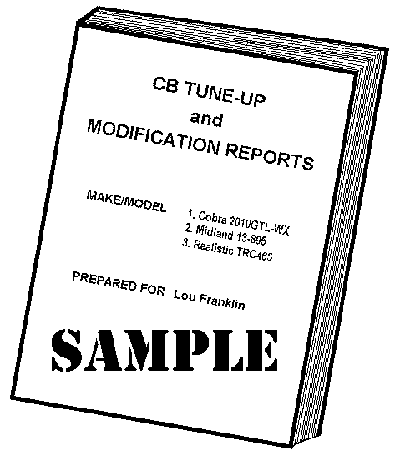

Here’s a simple and inexpensive way to get the inside information on your CB, before investing lots of time or money on a rig that may not have the capabilities you’re looking for. Our giant technical library has specific tune-up, peaking, and modification information for nearly all CBs. We’ve probably got something you need on 95% of all American models, plus many of the more popular foreign and “export” models. That’s over 1500 CBs, from rare old tube types to all the most common and popular crystal and PLL rigs.

Learn how to get maximum receiver sensitivity, RF transmitter power output, modulation and range from your AM or SSB rig by simple adjustments. No electronic knowledge required, and you use the radio’s own S/RF panel meter or an inexpensive SWR meter for tuning. Our T/M Reports also include mike wiring and crystal or PLL information for each specific model.

All of our CB TUNE-UP and MODIFICATION REPORTS are written in the same no-nonsense, plain language style that’s already made THE “SCREWDRIVER EXPERT'S” GUIDE the authority on do-it-yourself repairs. In these reports we show only the main adjustments for transmit power, modulation, and receiver sensitivity—no guessing at which controls and which parts do what. And each T/M REPORT is specially prepared just for you.

Includes:
• Parts layout showing where to find the main adjustments for receiver sensitivity and AM or SSB power
output and modulation. Includes simple tuning instructions.
• Basic description of the rig’s PLL or crystal synthesizer. Helps you find dead channel problems,
or modify your CB for extra frequencies. Detailed, simple explanation of PLL channel modifications
that you can often make using only a handful of parts or wires.
• For SSB radios, how to “strap over” the Clarifier to slide in TRANSMIT mode too.
• Mike wiring connections. No more guessing how to rewire a broken mike, or how to install a new one.

Here’s the perfect layman’s guide for anyone who wants the maximum performance from a CB radio. And how to get it without lots of previous electronic know-how or expensive special equipment. Even if you have no service information available, you’ll know what to do and how to do it for your CB model. Order one today!

When ordering...
1. Specify the manufacturer’s exact name and model. For example, a name like “Sears Roadtalker” is totally useless because many Sears models are called “Roadtalker.” “Sears 934.3831” is the kind of detail we need.
2. We do not have reports for Walkie-Talkies, or any 10M Ham rigs (HR2510, HTX100, RCI2950, etc.)
Published by:
CBC INTERNATIONAL • P.O. BOX 30655 • TUCSON AZ 85751 U.S.A.
TEL/FAX: 888-I-FIX-CBs (1-888-434-9227), (520) 298-7980
Internet: www.cbcintl.com • Email: Use email links at www.cbcintl.com

Build it! The TRI-POWER
Broadband Mobile RF Linear Amplifier

Construction plans completely rewritten & redesigned
for the new millennium. Easier to build than ever.

We’ve had plans for RF amps in our catalog since 1979. In 1993 we finished the first major revision since then, and we’re really proud of it. The original amp plans were certainly OK, and worth the low price. Thousands were sold, and people liked them. But we’re always trying to improve our stuff. That old amp was our first try at this, and had a few design problems and hard-to-find parts that made it tough for the average guy to build. Boy, we’ve learned a lot since then!

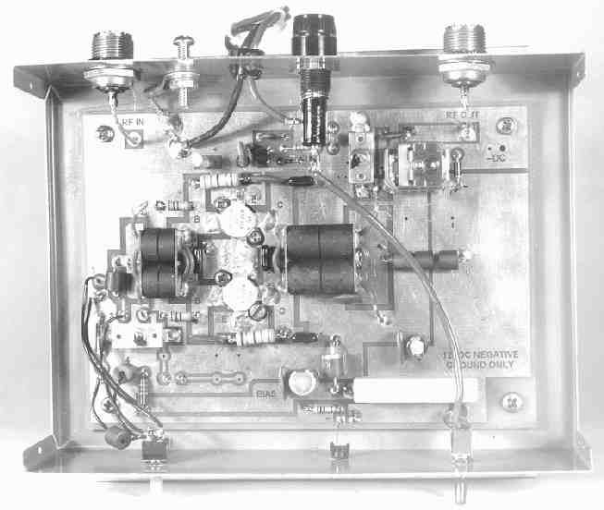All the old trouble spots have been cleaned up or fixed. Each of the three power options has been thoroughly tested. It’s now even easier to build using currently available parts. Many happy customers have already written to tell us how smoothly this new amp went together, and how well it works.

We’ve beefed up the whole booklet too, from 22 to 28 pages. All professionally written and illustrated, in a style similar to this page you’re now reading. Why settle for a few pages of illiterate junk from other so-called “publishers?” Get the real thing for the same price! And as always, you get the CBCI promise of “Satisfaction Guaranteed.”

The minimum cost to build a complete amp (including our plans) is about $100, depending on the power transistors you choose, how good you are at shopping for parts, what parts you already have laying around, etc. This compares favorably to the typical “$1 per watt” price of ready-made commercial amps, if you could even find them.

FEATURES:
• Broadbanded (3-30 MHz) push-pull design. No tuning required after a simple one-time setup procedure.
• Three power levels: 60-100-120W (100-140-180W PEP), depending on the transistors you choose when building.
• Includes trimmer adjustable input and output tuned circuits for perfect SWR matching. Just set it and forget it.
• All mode operation: AM, FM, CW, SSB.
• Internal SWR protection with rugged Motorola transistors.
• Bias switching lets you choose the most efficient method for Class C (AM/FM/CW) or Class AB (SSB) operation.
• Carrier operated T/R relay with separate drop-out timing delays to automatically match AM/FM or SSB operation.
• Switchable ON/OFF operation with LED indicator.
• Jumper adjustable input network matches 4W-10W RF drive levels for most popular low-power HF transceivers.
• Transient spike protection in mobile use.
• Double-sided PCB design uses extra heavy 2 oz. copper laminate for excellent RF stability and voltage regulation.

Not Legal For 27 MHz (Class D) CB Use
And it’s illegal to sell ready-made Linears or even amp kits in the USA. Please don’t ask us about them. The plans include reliable parts suppliers for everything you’ll need to complete this project, and have great fun learning too.

FREQUENCY MODIFICATION KITS
Published by:
CBC INTERNATIONAL • P.O. BOX 30655 • TUCSON AZ 85751 U.S.A.
TEL/FAX: 888-I-FIX-CBs (1-888-434-9227), (520) 298-7980
Internet: www.cbcintl.com • Email: Use email links at www.cbcintl.com

EXPANDER 160
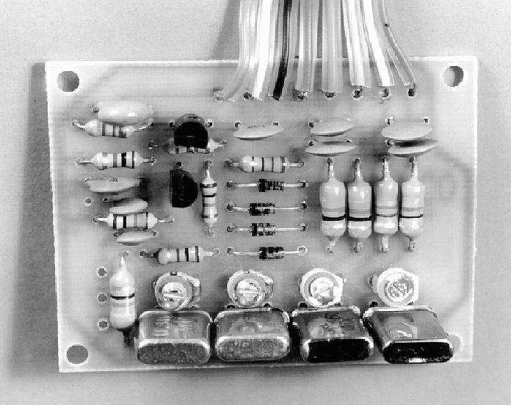
Electronic Crystal Switch & Crystal Oscillator

Expands frequency range of most PLL type CB radios. Adds up to 120 extra channels.*

Perfect for 10-Meter Ham conversions or the type of PLL modifications described in THE CB PLL DATA BOOK.

The EXPANDER 160 is a compact crystal oscillator which allows up to four crystal mixing frequencies to be injected into the PLL synthesizer circuit. This gives a potential of 4 x 40 = 160 channels. Since only one switch is needed, there’s no complicated switching as in binary or BCD PLL expansions, and no skips except for those already built into the Channel Selector. Wire jumpers allow the circuit to work as a remote crystal switch when its oscillator function isn’t needed, similar to the EXPANDER 240 described below. The small PC board fits inside the radio and connects to the PLL circuit, DC power, and your favorite type of hard switch (toggle, slide, rotary, etc.).
SHOWN ACTUAL SIZE

KIT $25 + $4 SHIPPING.
(PLANS + PC BOARD MAY BE
PURCHASED SEPARATELY.)

FEATURES:
• Buffered oscillator output prevents possible loading effects on the radio’s synthesizer circuit.
• Wide range crystal trimmers allow exact frequency adjustment.
• Remote diode switching eliminates the problem of stray capacitance found in long wire runs to mechanical switch boxes.
• Simple construction. High-quality PC board with screened parts overlay and solder mask. Kit includes all parts and wires (except the crystals and your choice of switch) plus detailed assembly and installation instructions.
• For all 23- or 40-channel PLL CBs using a loop mixing circuit. Includes: HD42851, LC7110, LC7113, LC7120, M58472P, M58473P, MB8719, MB8734, MC145f06, MM55116, MC14568, MSC42502P, MSM5907, NDC40013, NIS7261A, NIS7264B, PLL02A, REC86345, SM5104, SM5118, TC5080, TC9102, μPD858 (AM-only), μPD861, μPD2814, μPD2816, and μPD2824. (Some of these PLL circuits only require the switch function and will also work with the EXPANDER 240 kit.)
*Total bandwidth without retuning depends upon the specific radio circuit.

EXPANDER 240
Electronic Crystal Switch
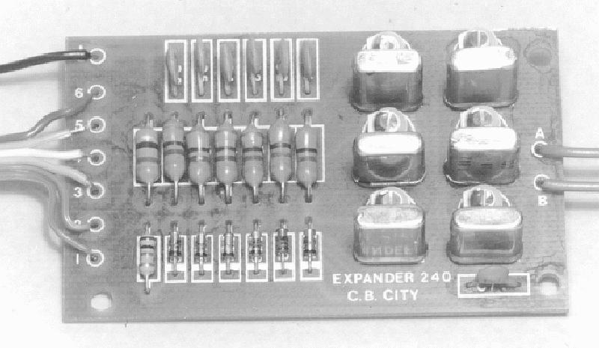
For all PLL type CB radios using a simple crystal local oscillator in the synthesizer mixer circuit. Also for 23-channel crystal-synthesized radios.

The EXPANDER 240 has all the features of the EXPANDER 160 but without the oscillator function (not needed for many conversions) and now with 6 crystal positions. This saves you money and simplifies modifications in radios that don’t require an external oscillator signal. Examples: all 23-channel crystal-synthesized radios, Cobra 140/142GTL type, Cobra 148/2000/2010GTL type, Uniden Grant XL, etc. Other applicable PLL types include the CPI chassis, HD42851, LC7110, LC7113, M58472P, M58473P, MB8719, MB8734, MC145106, MSM5907, NIS7161A, NIS7264B, PLL02A, REC86345, SM5104, TC5080, TC9102, μPD858 (AM-only models), and μPD861 (binary AM-only models).
SHOWN ACTUAL SIZE

KIT $20 + $4 SHIPPING.
(PLANS + PC BOARD MAY BE
PURCHASED SEPARATELY.)

IMPORTANT NOTES FOR BOTH EXPANDER KITS:
1. Due to the large number of crystal frequencies and mounting possibilities, the crystals and the hardware switch are not included in either kit shown on this page.
2. The following PLL circuits can’t be modified with these devices: C5121, LC7130, LC7131, LC7132, LC7136, LC7137, LC7185, MB8733, SM5123A, SM5124A, SM5125AM, SM5125B,TC9105, TC9106, TC9109, TC9119.
3. Installation should only be done by a qualified technician with access to the radio’s service manual or schematic.
IF UNSURE WHICH KIT TO USE, SEND US AN EMAIL OR A LARGE STAMPED S.A.E AND THE EXACT RADIO MAKE AND MODEL.

Manufactured by:
CBC INTERNATIONAL • P.O. BOX 30655 • TUCSON AZ 85751 U.S.A.
TEL/FAX: 888-I-FIX-CBs (1-888-434-9227), (520) 298-7980
Internet: www.cbcintl.com • Email: Use email links at www.cbcintl.com
“EXPORT” RADIO SERVICE MANUALS

For CYBERNET Main Chassis:
24-page book includes PCMA001S, PTBM125A4X/PTBM131A4X, PTBM133A4X, PTBM121D4X. Known models: Cobra GTL150, 148GTL-DX (fake), Colt 320FM, 320DX, 1200DX, 1600DX, 2000DX, 2400, Excalibur, Falcon 2000, Ham Int’l Concorde II, Concorde III, Jumbo III, Multimode III, HyGain 2795, 2795DX, 8795 (V), Intek 1200FM, Lafayette 1800, 2400, HB870AAFS, Midland 7001 export, Mongoose 2000, Nato 2000, Pacific 160, Palomar 2400, 5000, Starfire DX, Superstar 2000, 2200, Thunder 2000, Tristar 747, 777, 797, 848. Written by Lou Franklin, this is the only manual available. Complete specs, voltage measurements, theory, PLL charts, alignment instructions and layout, block diagram. Large 11" x 17" schematics for each chassis.

For UNIDEN Main Chassis:
26-page book includes PB010 chassis (Cobra 148GTL-DX, President RICHARD, Superstar 360FM), PC999 (GRANT), and PB042 (JACKSON) in one complete book. Also applicable to Stalker 9FDX export, and President/Uniden AR144 type chassis. Written by Lou Franklin, this is the only manual available. Complete specs, voltage measurements, stage gain measurements, theory including detailed PLL description, complete alignment instructions and layouts, block diagram. Special addition describes modifications and improvements. Large 11" x 17" schematics for each chassis.

— SEE ORDER FORM AT END FOR PRICES —

UNIQUE CB BEAM ANTENNA IMPROVES SKIP & GROUND WAVE SIGNALS
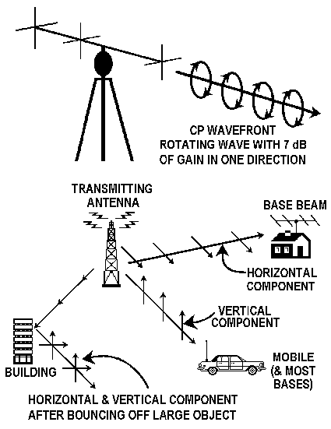
As featured in the June, 1980 issue of S/9 HOBBY RADIO

Now you can have the best of all antenna worlds: vertical polarization, horizontal polarization, and everything in between automatically, and with no switching. Circular Polarization (CP) for CB has arrived!

Not available commercially. Build your own while saving money and improving your communications range and antenna knowledge.

FEATURES
• Improved performance on skip signals.
• Improved performance in hilly areas, or between tall buildings.
• Talk to mobiles (vertical) or bases (horizontal or vertical) automatically
and without switching.
• 3-element beam design gives 7 dB gain over a dipole.
• Simple construction with common materials. Detailed, non-technical
assembly and tuning instructions.

Circular Polarization (CP) is an idea borrowed from FM and TV broadcasters, who were faced with the problem of getting out to both cars (vertical) and homes (horizontal). CP is basically a rotating, twisting radio wave containing properties of all polarization angles, including all those in between vertical and horizontal. (Such as skip signals, signals from moving mobile whips, or signals bounced off hills or buildings.) Regardless of the antenna type used, most CB signals change their polarization as soon as they bounce off an object. With CP, it doesn’t matter. You’ll get out better and hear better, even if the other station is using a conventional antenna.

The other big advantage of CP is its elimination of multipath fading. You’ve probably experienced this as “ghosts” on your TV set when an airplane passed overhead. Or as fading when talking to a moving mobile. Since CP receives all polarization angles, it doesn’t matter what happens to the other station’s signal on its way to you. And when transmitting, the fact that your signal contains all types of polarization increases your chance of being heard by both local and skip stations. Finally, add to this the 7 dB beam effect. This is equivalent to a five-fold power increase! (A 4-watt CB sounds like 20 watts!)

Our plans include full details on mechanical assembly, matching, element dimensions, etc. And you’ll also get information on building a second type of CP antenna, as well as a 3-element Yagi beam antenna. That’s three antenna plans for the price of one!
Published by:
CBC INTERNATIONAL • P.O. BOX 30655 • TUCSON AZ 85751 U.S.A.
TEL/FAX: 888-I-FIX-CBs (1-888-434-9227), (520) 298-7980
Internet: www.cbcintl.com • Email: Use email links at www.cbcintl.com
The MASTER LIST of PLL CBs

We’ve computerized every known American and export model into a simple alphabetical list by brand name. This lets you see at a glance exactly which chip the model uses, whether it can be modified for other frequencies (YES/NO), and which SAMS Fotofacts (if any) it’s in. Modification details for radios with a “YES” classification can then be further understood by reading and studying our TUNE-UP and MODIFICATION REPORTS, or THE CB PLL DATA BOOK. Shown below is a very small sample of the list.

MODEL PLL CHIP MODIFIABLE? Y/N SAMS FOTOFACTS #
Cobra 148GTL-DX (early, PC879) MB8719 yes n/a
Cobra 148GTL-DX (late, PB010) MC145106 yes n/a
Cobra 148GTL-DX (fake, PCMA001S) PLL02A yes n/a
Cobra GTL150 PLL02A yes n/a
Cobra 1000GTL µPD2816 yes 235
Cobra 2000GTL MB8719/MB8734 yes 251
Colt SX33 PLL02A yes 257
Colt 210 LC7131 no 292

With the MASTER LIST you’ll know in advance which radio is suitable for modifications before you or your friends buy it. If you service CBs, this will be a great help that your customers will appreciate. If you’re about to buy a new one yourself, you’ll know exactly what to avoid. Attention Hams: Don’t go to that next flea market looking for a 10-Meter CB candidate without your copy of the MASTER LIST handy. Otherwise you might end up with a “bargain” that wasn’t!

The MASTER LIST includes virtually every 23- and 40-channel American PLL model, and nearly every “export” model that’s ever been used here. Plus many of the standard European models. Currently over 1,000 listings!

SEE ORDER FORM AT END FOR PRICES

CB SOURCES SUPPLY LIST

The question most often asked by our mail customers is, “Where can I find ______________?” (Fill in the blank with just about anything related to electronics or CB Radio.) It seems most people just don't know where to start looking for the radio supplies they want or need. Look no more! We’ve created a special list, by category, just for you.

Our CB SOURCES SUPPLY LIST helps you find CB and Ham equipment and related electronic supplies, quickly and easily. Some of the listed names will even direct you to more detailed lists. You’ll find almost anything here for your radio shack. We’ve used many of these firms personally, so we know they’re reliable, well stocked, and have good mailorder prices. And we’ve included toll-free “800” numbers where available to make your shopping even easier. Get your copy today!

Here’s a summary of the main categories:

• CB Equipment — Retail
• CB Equipment — Wholesale
• CB Radio & Antenna Manufacturers
• CB Specialties & Accessories
• Ham Radio Equipment
• Japanese ICs & Transistors
• Tubes & Antique Radio Supplies
• Electronic Parts — Surplus
• Electronic Parts — New
• Test Equipment — New
• Test Equipment — Surplus
• Electronic Books & Magazines

Published by:
CBC INTERNATIONAL • P.O. BOX 30655 • TUCSON AZ 85751 U.S.A.
TEL/FAX: 888-I-FIX-CBs (1-888-434-9227), (520) 298-7980
Internet: www.cbcintl.com • Email: Use email links at www.cbcintl.com
EXPANDER 160 & EXPANDER 240 Application Notes

Many people have asked about which expander kit is best for their particular application. Let’s try to clear this up.

Generally speaking, any radio which can use the EXPANDER 240 can also use the EXPANDER 160, but the reverse is not true. That’s because only the EXPANDER 160 includes the oscillator function, which you’d need for many PLL radios. You’d be paying more for an EXPANDER 160 in those applications where you really only need the EXPANDER 240’s crystal switching. You might also want to remove the EXPANDER 160 some day and re-install it in another rig that does need the oscillator function, giving you more flexibility.

On the other hand, the EXPANDER 240 has 6 rather than 4 crystal positions and could be used in the older 23-channel radios with crystal synthesizers. In those rigs the EXPANDER 240 would add a total of [5 x 4 related channel groups] = 20 extra channels. (The 6th slot must be reserved for an existing radio synthesizer crystal.) Not very cost-effective for crystal CBs though: there’s the kit cost, the cost of 5 crystals, and the cost of paying a tech to build and install it if you can’t do it yourself. PLL rigs are the most practical.

We call these kits “160” and “240” because any PLL CB using a mixing signal can theoretically have 40 channels per mixing crystal: [4 x 40] = 160 and [6 x 40] = 240, respectively. Few American CBs are broadbanded enough to tune this much range though, with the limit typically 120–130 channels total. For example, the popular MB8719/MB8734 Uniden SSB models will tune a maximum of about 130–140 channels, which means 3 full 40-channel bands, plus a partial band on the 4th mixing crystal. Or two full bands on the two middle crystals and two partial bands on the end crystals, depending on where you set the VCO and mixer tuning stages.

Listed below are many common radios by chassis type, and which kit to use. If your rig’s not on this list, send us a stamped self-addressed envelope (SASE) or E-Mail message with the exact model number. We’ll tell you what if anything can be done to it. NOTE! If you don’t understand this discussion about mixing, you are not ready for this! Get a pro tech to do the hard work for you.

EXPANDER 160:
1. Any 23-channel crystal rig. (But only 12 extra channels, where the EXPANDER 240 would get you 20 extra channels.)
2. Any PLL rig using the 15.360 MHz loop tripler mixing scheme. Chips with this method include the LC7120, SM5107, µPD858 (AM 2-crystal scheme only), µPD861, µPD2810, µPD2812, µPD2814, µPD2816, and µPD2824 (SSB).
3. Any late Cybernet PLL02A AM PLL chassis using the 2-crystal scheme of 10.240 MHz and 10.695 MHz. In this circuit the 10.240 MHz PLL reference signal is doubled to 20.480 MHz, and you would replace that signal.
4. Any other PLL rig using a mixing signal that’s not directly derived from a separate mixing crystal. For example all NDI SSB rigs (SBE Sidebander IV, V, Console V, Console VI, Johnson Viking 4730, Messenger 4730, Pace 1000MC/BC, etc.) use a 10 MHz PLL crystal reference, and part of that oscillator signal is sampled off and doubled to 20 MHz to use for loop mixing. In those rigs you’d inject your own new signals in the 20–21 MHz range using an external oscillator.

EXPANDER 240:
1. All 23-channel crystal models.
2. Any early Cybernet PLL02A AM PLL chassis using the 3-crystal scheme of 10.240 MHz, 10.695 MHz, and 11.8066 MHz. Here you’d switch in new crystals to replace the 11.8066 MHz signal, which is being tripled to 35.420 MHz anyway.
3. All Cybernet PLL02A SSB American chassis using the 10.0525 MHz mixing crystal, or all “export” multimode chassis using a bank of mixing crystals in either the 10 MHz or 20 MHz range.
4. All the MB8719/MB8734 PLL SSB chassis. Replace the 11.1125 MHz or 11.325 MHz tripler crystal.
5. All the µPD858 AM 3-crystal models. These use 10.240 MHz, 10.695 MHz, and 36.570 MHz.
6. All the µPD858 SSB and SM5104 SSB models. CAUTION! This chassis uses 3 separate mixing crystals, one each for AM, LSB, and USB. Therefore the kit would only work for one mode. That’s fine for 10-Meter Novice conversions if all you care about is USB, but for full CB expansion you’d need three kits for all-mode coverage. Obviously, not very practical.
7. Realistic TRC448, Wards GEN719A: same situation as #6.
8. All Royce models with the “sardine can” type of sealed PLL unit. These generally use a 36 MHz loop mixing signal and the specific PLL chip doesn’t matter. What does matter is that you’d have to run the EXPANDER 240 switching wires into the sealed unit. These wires would be longer than the normal kit mounting location and could cause oscillator instability.
9. Realistic TRC459, TRC480. (Change the 18 MHz mixing crystal.)
10. Any other PLL circuit using a discrete crystal oscillator for loop mixing. You would switch in new crystals to replace that signal. Usually the mixing crystal is around 36 MHz (or a tripled 12 MHz), although a few odd circuits use other crystal frequencies.

For more specific synthesizer details, you might want to order and study our CB TUNE-UP and MODIFICATION REPORTS for your specific radio before proceeding. These include details on suggested new mixing crystals, Clarifier strapovers, peaking, etc.

CBC INTERNATIONAL • P.O. BOX 30655 • TUCSON AZ 85751 U.S.A.
TEL/FAX: 888-I-FIX-CBs (1-888-434-9227), (520) 298-7980
Internet: www.cbcintl.com • Email: Use email links at www.cbcintl.com



MAIL-IN ORDER FORM

We accept VISA/MASTERCARD on orders over $25.

Please mark desired items and quantities at left. Make sure total on next page agrees with the items you check here!

____ THE "SCREWDRIVER EXPERT'S" GUIDE TO PEAKING OUT & REPAIRING CB RADIOS $31.95

____ THE CB PLL DATA BOOK $24.95

____ UNDERSTANDING & REPAIRING CB RADIOS $49.95

____ REPAIRMAN'S SPECIAL! All three of the above books (You save $22.00) $84.95

____ CB TUNE-UP/MODIFICATION REPORTS / Price per radio model $7.00

DON'T FORGET TO SPECIFY EXACT MODEL(S) ____ SPECIAL! 2 REPORTS (You save $4.00) $10.00

MAKE/MODEL #1 #2

#3 #4

ALTERNATE CHOICE(S)
Please include alternate model in case no data available for first choice. If you have no alternate, this portion of your payment will be refunded or credited. NOTE: Base & mobile CBs only. No Reports for any walkie-talkie or Ham rigs. (HR2510, RCI2950, etc.)

____ CP BEAM ANTENNA - Complete 13-page construction plans $10.00

CHANNEL GUARD IF INTERFERENCE FILTER
____ For 7.8 MHz SSB models. (Older 40-Ch. Cobra, Uniden, Toshiba, & NDI PLL types, most 23-Ch. crystal types.) $36.95
____ For 10.695 MHz SSB models. (All PLL02A & μPD2824 PLL, all Galaxy, RCI, Superstar, & other Uniden "clones".) $36.95
Also for most AM or AM-FM models having a 10.695 MHz IF. (Replaces our discontinued 455 KHz ceramic filter. SPECIFY MODEL!)

____ SPECIAL! Any two CG filters (You save $9.00) $64.95

IMPORTANT! Please specify exact radio to use with CG filter

DYNAMIC SPEECH PROCESSOR
____ Complete kit. All parts, wires, PC board, detailed assembly & installation instructions $41.95
____ Complete construction plans + PC board only. (You supply all other parts needed.) $12.00

____ LINEAR RF AMPLIFIER - Complete 28-page construction plans. Everything you ever wanted to know! $15.00

EXPANDER 160 CRYSTAL OSCILLATOR & SWITCH
____ Complete kit. All parts (except crystals & switch), wires, PC board, detailed assembly & installation instructions $25.00
____ Complete construction plans + PC board only. (You supply all other parts needed.) $12.00

EXPANDER 240 ELECTRONIC CRYSTAL SWITCH
____ Complete kit. All parts (except crystals & switch), wires, PC board, detailed assembly & installation instructions $20.00
____ Complete construction plans + PC board only. (You supply all other parts needed.) $12.00

____ GALAXY–RANGER RADIO SERVICE MANUAL $29.95
____ UNIDEN EXPORT RADIO SERVICE MANUAL $29.95
____ CYBERNET EXPORT RADIO SERVICE MANUAL $29.95
____ TECH SPECIAL! All 3 service manuals (You save $15.00) $74.95

7-08

____ THE MASTER LIST OF PLL MODELS: IC CHIPS USED, MODIFIABILITY, etc. $10.00

____ CB SOURCES PARTS LIST: CB manufacturers, wholesale/retail dealers, new/surplus parts, books, magazines $10.00

____ 4.7 µH RF CHOKES – Put in series with Clarifier’s varactor diode to increase slide range up to several KHz 5-pack $7.00
____ 470 µH RF CHOKES - Great for general RF filtering. Kills RF feedback & squeal when nothing else works 5-pack $7.00

TOLL-FREE VISA/MC FAX ORDERS: 888-I-FIX-CBs (1-888-434-9227) • Local: (520) 298-7980
Email: Use email links at www.cbcintl.com • Secure Web Order Form: https://www.cbcintl.com/secure.htm
(continued on next page)
FILL OUT AND MAIL TODAY SATISFACTION GUARANTEED

ORDERING INFORMATION
CBCI has no control over the technical skill of the purchaser, nor the end use of our products or information. CBCI assumes no liability for improper or illegal use, or improper construction or installation. Exchanges made only for defects or shipping damage. We only repair our own kits as noted in the kit's construction plans, and we do not accept shipments of non-CBCI items for repair. (Our plans always include sufficient service data.) All CBCI books and plans have an unconditional money-back guarantee (less shipping cost) if not completely satisfied. Note however that all hardware sales are final; no refunds, credits, or exchanges.

Payment: Full payment in U.S. funds with order. We accept cash, Money Orders, Cashier's Check, or VISA/MASTERCARD. No foreign checks accepted. Personal checks will delay shipment up to 10 business days to clear your bank. Large or quantity orders sent UPS or Priority Mail at our discretion. Prices subject to change without notice. Sorry, no C.O.D. or billing.

SAVE MONEY! Help cut our paperwork and get a 15% discount for cash payment. "Cash" means exactly that-cash. (We've been in business since 1976, and some people ask for this.) We accept paper only in US$ or equal foreign exchange (paper) in C$, A$, NZ$, UK£, DM, FFr, SFr, HFl, J¥, ATS, SAR. PLEASE DON'T SEND COINS. Round up Line 6 total to nearest whole dollar. Wrap in foil for added security. No discount for Money Orders or Cashier's Checks. If you're not comfortable sending cash, use any of the other methods shown at the full price. The U.S. Postal Service is still the most reliable in the world, and First Class letters are rarely lost.

IMPORTANT-We are book sellers, not book keepers. We know you're anxious to get this stuff, but things like math mistakes, missing or invalid credit card numbers, and unreadable handwriting or FAXes will delay your order. When they happen we must return your letter or FAX, so it takes that much longer to mail us back your corrected Order Form. Please follow all instructions carefully!

1. Total cost for items checked on Order Form $

2. Subtract 15% discount if sending cash. NOTE: "Cash" means exactly that-"Green Stamps" only! $ ( )

3. Subtract any previous Credit Memos (enclose your original with this order) $ ( )

4. Arizona residents must add 7% sales tax $

5. Add required shipping charges. Minimum $6. See Chart below $

HOW TO FIGURE SHIPPING CHARGES: Add up the weight (in oz.) of each item or special combo to get the total weight.
Then look under the class of Postal service you want to find the shipping cost. New postal rates as of May 12, 2008, apply.

PRODUCT WEIGHTS (in ounces/oz.):
Kits, CG filter, small parts, schematics, CB Sources & Master lists = 6 oz. Single copy of “Screwdriver Expert’s” or CB PLL DATA book = 11 oz.
Tuneup/Mod. Reports, single Galaxy, Uniden, or Cybernet service book = 8 oz Tech combo Galaxy + Uniden + Cybernet service books = 15 oz.
Single copy of Understanding & Repairing CB Radios book = 28 oz. Special combo “Screwdriver Expert’s” + PLL DATA + Understanding CB book = 44 oz.

TOTAL  WEIGHT | 1st Class / Priority (Air Mail)  (U.S. only, 3-5 days after we ship) |  | CANADA  AIR MAIL | MEXICO  AIR MAIL | ALL OTHER  AIR MAIL COUNTRIES  BY ZONE*  Z-1 Z-2
TOTAL  WEIGHT | W. of Mississippi: | E. of Mississippi plus AK, HI, PR, VI: | CANADA  AIR MAIL | MEXICO  AIR MAIL | ALL OTHER  AIR MAIL COUNTRIES  BY ZONE*  Z-1 Z-2
0 - 16 oz. | $6.00 | $6.00 | $6.00 | $7.00 | $10.00 $10.00
17 - 32 oz. | $7.00 | $7.00 | $8.00 | $12.00 | $17.00 $16.00
33 - 48 oz. | $8.00 | $11.00 | $12.00 | $18.00 | $23.00 $22.00
49 - 64 oz. | $10.00 | $13.00 | $16.00 | $23.00 | $29.00 $29.00
Over 64 oz: Add proportionately more. Excess will be refunded.

*Z-1 = Bahamas, Barbados, Central America, all Caribbean islands, Europe, U.K.
*Z-2 = Africa, Asia, Australia, New Zealand, Philippines, Japan, all Pacific islands, Middle East., South America.

6. Net total of Lines 1-5. This is the total amount to be enclosed or charged $
NOTE: $25 minimum for credit cards.
FAX your VISA/MC order!
(888) 434-9227, (520) 298-7980
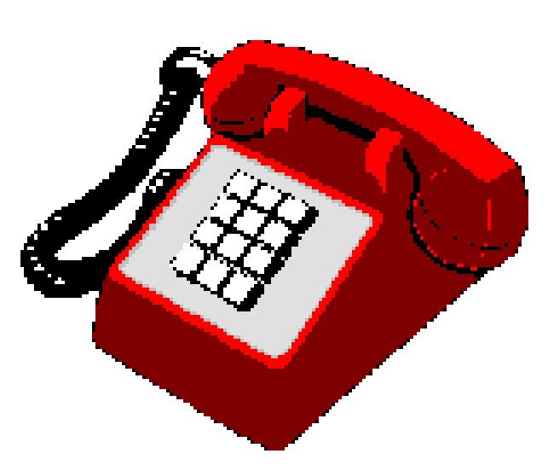

PLEASE PRINT IN DARK INK, ESPECIALLY FOR FAXes!

NAME E-MAIL

ADDRESS CALL SIGN

CITY STATE/COUNTRY ZIP

VISA/MASTERCARD # EXP. DATE
IMPORTANT-Print the cardholder's name (you, a parent, a friend, etc.) exactly as it appears on the VISA or MASTERCARD.
Mail to: CBC INTERNATIONAL • P.O. Box 30655 • Tucson AZ 85751 U.S.A. • Email: Use email links at www.cbcintl.com
Check here if you'd like to be on our Email list for future product information.

Is this your first order? ______________ If YES, how did you learn about us?

Magazine (which one?) Friend On The Air
7-08 THANK YOU FOR YOUR BUSINESS! NEW CATALOG SENT WITH EVERY ORDER

